Fun With Food!

Five Little Fruits Lyrics

Five little fruits jumping on the bed.  
apple fell off and bumped his head.  
banana called the doctor and the doctor said,  
“No more fruits jumping on the bed!”

Four little fruits jumping on the bed.  
banana fell off and bumped his head.  
orange called the doctor and the doctor said,  
“No more fruits jumping on the bed!”

Three little fruits jumping on the bed.  
orange fell off and bumped his head.  
strawberry called the doctor and the doctor said,  
“No more fruits jumping on the bed!”

Two little fruits jumping on the bed.  
strawberry fell off and bumped his head.  
grapes called the doctor and the doctor said,  
“No more fruits jumping on the bed!”

One little fruit jumping on the bed.  
grapes fell off and bumped his head.  
apple called the doctor and the doctor said,  
“Put those fruits right to bed!

I like To Eat Apples And Bananas

I like to eat, eat, eat apples and bananas  
I like to eat, eat, eat apples and bananas

A  
A lake to ate, ate, ate ay-ples and ba-nay-nays  
A lake to ate, ate, ate ay-ples and ba-nay-nays

E  
E leke to eat, eat, eat ee-ples and bee-nee-nees  
E leke to eat, eat, eat ee-ples and bee-nee-nees

I  
I like to ite, ite, ite i-ples and by-ny-nys  
I like to ite, ite, ite i-ples and by-ny-nys

O  
O loke to ote, ote, ote oh-ples and bo-no-nos  
O loke to ote, ote, ote oh-ples and bo-no-nos

U  
U luke to oot, oot, oot oo-ples and boo-noo-noos  
U luke to oot, oot, oot oo-ples and boo-noo-noos

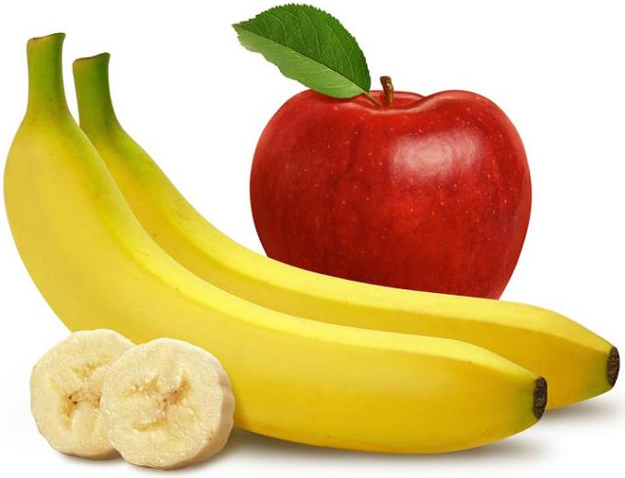

Put Your Apple

Put your apple in the air,

Hold it high and leave it there,

Now reach down and touch your toes.

Put your apple on your back

Now please lay it on your lap.

Put your apple in the air,

Hold it high and leave it there,

Now reach down and touch your toes.

Put your apple on your back

Now please lay it on your lap.

Apples are yummy

Apples are yummy, yummy, yummy, yummy

Apples are yummy, yummy, yummy, yummy

Apples are yummy, yummy , yummy

Bananas are so yummy too.

Bananas are yummy, yummy, yummy, yummy

Bananas are yummy, yummy, yummy, yummy

Bananas are yummy, yummy , yummy

Strawberries are so yummy too.

Strawberries are yummy, yummy, yummy, yummy

Strawberries are yummy, yummy, yummy, yummy

Strawberries are yummy, yummy , yummy, yummy

Grapes are so yummy too.

Grapes are yummy, yummy, yummy, yummy

Grapes are yummy, yummy, yummy, yummy

Grapes are yummy, yummy , yummy, yummy

Apples are so yummy too.

Apples are yummy, yummy, yummy, yummy

Apples are yummy, yummy, yummy, yummy

Apples are yummy, yummy , yummy

Bananas are so yummy too.

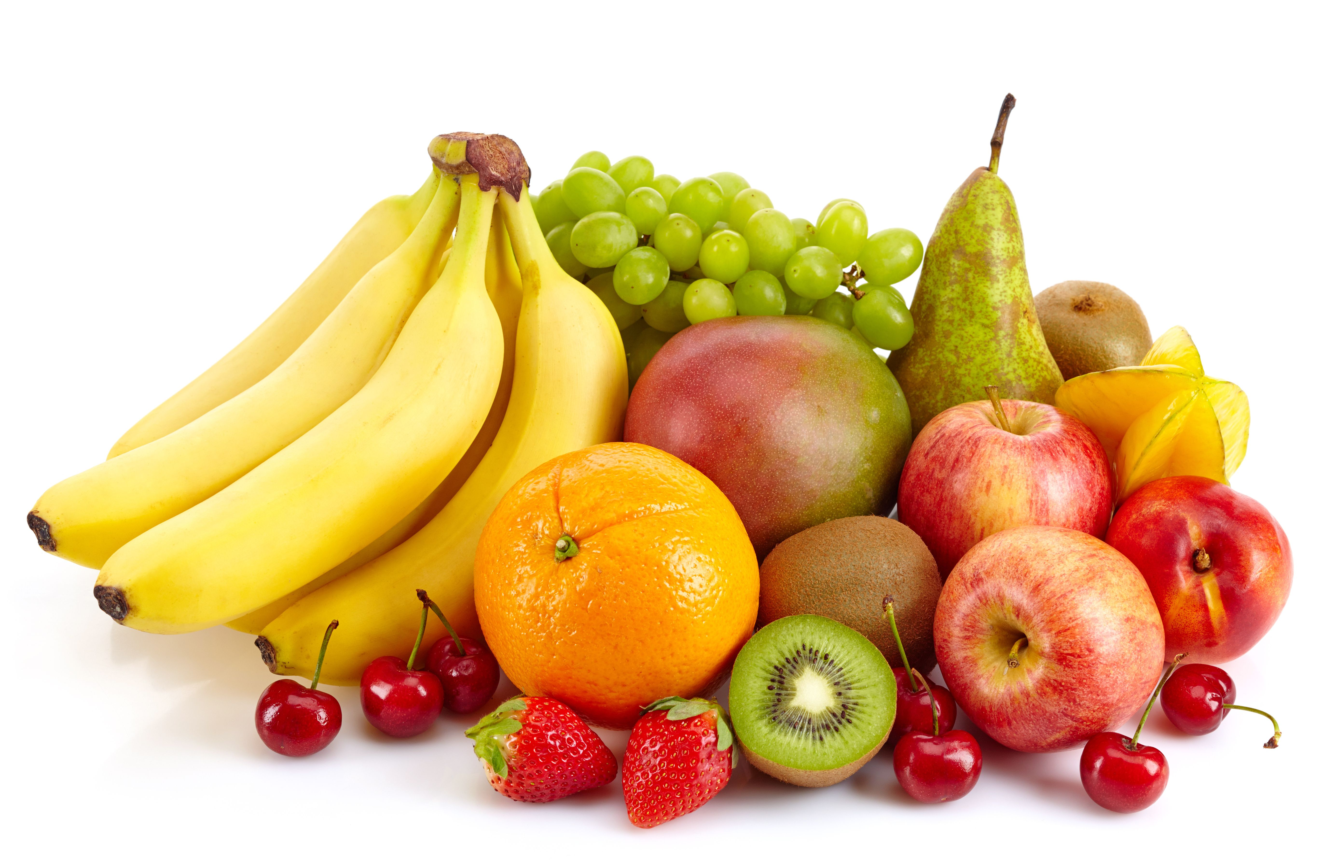

Five fat Sausages

Five fat sausages  
sizzling in a pan  
one went „pop“  
the other went „bang“.  
  
Four fat sausages  
sizzling in a pan  
one went „pop“  
the other went „bang“.  
  
Three fat sausages  
sizzling in a pan  
one went „pop“  
the other went „bang“.  
  
Two fat sausages  
sizzling in a pan  
one went „pop“  
the other went „bang“.  
  
One fat sausage  
sizzling in a pan  
one went „pop“  
the other went „bang“.  
No fat sausages  
sizzling in a pan  
That’s bad luck  
so we’ll eat cold ham!

One potato, two potatoes, three potatoes, four.

One potato, two potatoes, three potatoes, four.  
Five potatoes, six potatoes, seven potatoes, more.  
One potato, two potatoes, three potatoes, four.  
Five potatoes, six potatoes, seven potatoes, more.

One potato, two potatoes, three potatoes, four.  
Five potatoes, six potatoes, seven potatoes, more.

One potato, two potatoes, three potatoes, four.  
Five potatoes, six potatoes, seven potatoes, more.  
One potato, two potatoes, three potatoes, four.  
Five potatoes, six potatoes, seven potatoes, more.

One potato, two potatoes, three potatoes, four.  
Five potatoes, six potatoes, seven potatoes, more.

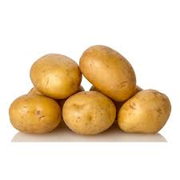

**Today is Monday, today is Monday.  
Monday string beans.  
All you hungry children, come and eat it up!**

**Today is Tuesday, today is Tuesday.  
Tuesday spaghetti,  
Monday string beans.  
All you hungry children, come and eat it up!**

**Today is Wednesday, today is Wednesday.  
Wednesday soup,  
Tuesday spaghetti, Monday string beans.  
All you hungry children, come and eat it up!**

**Today is Thursday, today is Thursday.  
Thursday roast beef,  
Wednesday soup, Tuesday spaghetti, Monday string beans.  
All you hungry children, come and eat it up!**

**Today is Friday, today is Friday.  
Friday fresh fish,  
Thursday roast beef, Wednesday soup,  
Tuesday spaghetti, Monday string beans.  
All you hungry children, come and eat it up!**

**Today is Saturday, today is Saturday.  
Saturday chicken,  
Friday fresh fish, Thursday roast beef, Wednesday soup,  
Tuesday spaghetti, Monday string beans.  
All you hungry children, come and eat it up!**

**Today is Sunday, today is Sunday.  
Sunday ice-cream,  
Saturday chicken, Friday fresh fish,  
Thursday roast beef, Wednesday soup,  
Tuesday spaghetti, Monday string beans.  
All you hungry children, come and eat it up!**

Baked A Cake

If I knew you were comin' I'd've baked a cake, baked a cake, baked a cake  
If I knew you were comin' I'd've baked a cake  
Howdya do, howdya do, howdya do?

Had you dropped me a letter, I'd a-hired a band, grandest band in the land  
Had you dropped me a letter, I'd a-hired a band  
And spread the welcome mat for you

If I knew you were comin' I'd've baked a cake, baked a cake, baked a cake  
If I knew you were comin' I'd've baked a cake  
Howdya do, howdya do, howdya do?

Had you dropped me a letter, I'd a-hired a band, grandest band in the land  
Had you dropped me a letter, I'd a-hired a band  
And spread the welcome mat for you

