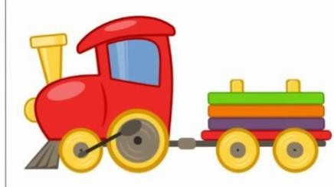

**The Wheels on the Bus**

The wheels on the bus go round and round  
Round and round  
Round and round  
The wheels on the bus go round and round  
All 'round the town

The wipers on the bus go swish, swish, swish  
Swish, swish, swish  
Swish, swish, swish  
The wipers on the bus go swish, swish, swish  
All 'round the town

The driver on the bus goes 'move on back'  
Move on back  
Move on back  
The driver on the bus goes 'move on back'  
All 'round the town

The people on the bus go up and down  
Up and down  
Up and down  
The people on the bus go up and down  
All 'round the town

The horn on the bus goes beep, beep, beep  
Beep, beep, beep  
Beep, beep, beep  
The horn on the bus goes beep, beep, beep  
All 'round the town

The baby on the bus goes 'whaa whaa whaa'  
Whaa whaa whaa  
Whaa whaa whaa  
The baby on the bus goes 'whaa whaa whaa'  
All 'round the town

The parents on the bus go 'shh, shh, shh'  
Shh, shh, shh  
Shh, shh, shh  
The parents on the bus go 'shh, shh, shh'  
All 'round the town

## Freight Train

## Clickety-clack, clickety-clack, What's that coming down the track? A freight train!

Freight train coming down the track, Chugga chugga chugga.

Clickety-clack, clickety-clack, What's that coming down the track? A steam engine!

Steam engine coming down the track, Chugga chugga chugga.

Clickety-clack, clickety-clack, What's that coming down the track? A box car!

Box car coming down the track, Chugga chugga chugga.

Coming and going and rolling down the track. Coming and going and rolling down the track.

Clickety-clack, clickety-clack, What's that coming down the track? A tank car!

Tank car coming down the track, Chugga chugga chugga

Coming and going and rolling down the track. Coming and going and rolling down the track.

Clickety-clack, clickety-clack, What's that coming down the track? A freight train!

Freight train coming down the track, Chugga chugga chugga

**Big Red Car**

Toot toot, chugga chugga, big red car

We'll travel near and we'll travel far Toot toot, chugga chugga,

big red car

We're gonna ride the whole day long

Simon's in the back seat Singing "lalala"

Simon's in the back seat

Of the big red car

Toot toot, chugga chugga, big red car

We'll travel near and we'll travel far Toot toot, Chugga chugga, big red car

We're gonna ride the whole day long

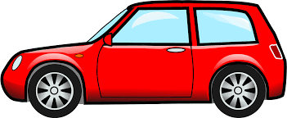

## Captain of the Boat

Ahoy! Weigh the anchor!

I'm the captain of the boat  
And I really like to float on the water  
(Out on the water)  
So put on your sailing best  
Grab a life vest  
And take a ride on a boat with me

We'll take an ocean liner  
It's really large

That's big!

And with a tug boat  
We'll tow a barge  
A sailboat is moving  
When the wind is blowing  
But if it isn't,  
We better start rowing!

I'm rowing!

Wonders can be seen  
Sitting in a submarine  
If it's just me and you  
We can take a canoe  
Yeah!

Where's my paddle?

I'm the captain of the boat  
And I really like to float on the water  
(Out on the water)  
So put on your sailing pants  
Do your sailing dance  
Take a ride on a boat with me

## 