RRST Body Parts and Action Songs

Shake your sillies out
I've gotta shake, shake, shake my sillies out
Shake, shake, shake my sillies out
Shake, shake, shake my sillies out
And wiggle my waggles away
I've gotta clap, clap, clap my crazies out
Clap, clap, clap my crazies out
Clap, clap, clap my crazies out
And wiggle my waggles away
I've gotta jump, jump, jump my jiggles out
Jump, jump, jump my jiggles out
Jump, jump, jump my jiggles out
And wiggle my waggles away
I've gotta yawn, yawn, yawn my sleepies out
Yawn, yawn, yawn my sleepies out
Yawn, yawn, yawn my sleepies out
And wiggle my waggles away
I've gotta shake, shake, shake my sillies out
Shake, shake, shake my sillies out
Shake, shake, shake my sillies out
And wiggle my waggles away
And wiggle my waggles away

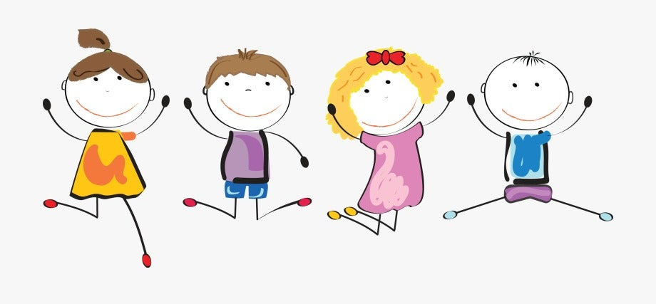
Im So Happy
Na Na Na I'm So Happy
O So Happy, Sing With Me
Na Na Na I'm So Happy O So Happy Sing with Me
Clap Clap Clap Your Hands
Stamp Stamp Stamp Your Feet
Swing Swing Swing Your Arms
Dance Everybody And Sing With Me
Na Na Na I'm So Happy
O So Happy, Sing With Me
Jump Jump Jump Around
Touch The Sky And Touch The Ground
Shake Shake Shake Your Hips
I Know A Song And It Goes Like This
Na Na Na I'm So Happy O So Happy Sing With Me
Clap Clap Clap Your Hands
Stamp Stamp Stamp Your Feet
Swing Swing Swing Your Arms
Dance Everybody And Sing With Me
Jump Jump Jump Around
Touch The Sky And Touch The Ground
Shake Shake Shake Your Hips I Know A Song And It Goes Like This
Na Na Na I'm So Happy O So Happy Sing With Me
Na Na Na I'm So Happy O So Happy Sing With Me
Na Na Na I'm So Happy O So Happy Sing With Me

Head, shoulders, knees and toes
Head, shoulders, knees and toes
Knees and toes
Head, shoulders, knees and toes
Knees and toes
And eyes, and ears, and mouth, and nose
Head, shoulders, knees and toes
Knees and toes
Head, shoulders, knees and toes
Knees and toes
Head, shoulders, knees and toes
Knees and toes
And eyes, and ears, and mouth, and nose
Head, shoulders, knees and toes
Knees and toes

If Your Happy and you know it
If you're happy and you know it, clap your hands
If you're happy and you know it, clap your hands
If you're happy and you know it, then your face will surely show it
If you're happy and you know it, clap your hands

If you're happy and you know it, stomp your feet
If you're happy and you know it, stomp your feet
If you're happy and you know it, then your face will surely show it
If you're happy and you know it, stomp your feet

If you're happy and you know it, shout "Hurray!" (Hurray!)
If you're happy and you know it, shout "Hurray!" (Hurray!)
If you're happy and you know it, then your face will surely show it
If you're happy and you know it, shout "Hurray!" (Hurray!)

If you're happy and you know it, do all three (hurray!)
If you're happy and you know it, do all three (hurray!)
If you're happy and you know it, then your face will surely show it
If you're happy and you know it, do all three (hurray!)

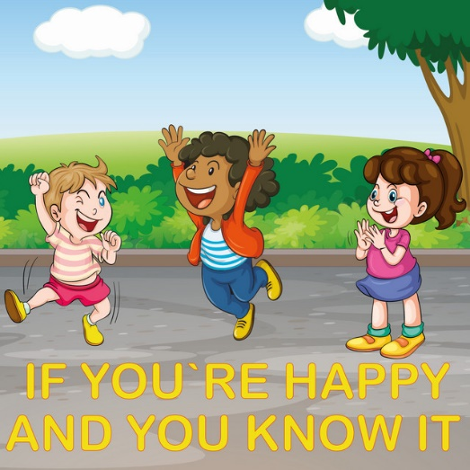

Shake, shake, shake it out
Shake, shake, shake it out
Shake it out!
Shake, shake, shake it out
Shake, shake, shake it out
Shake it out!
Shake your arms
Shake, shake, shake your arms
Shake your arms
Shake, shake, shake your arms
Shake your arms
Shake, shake, shake your arms
And freeze!
Shake, shake, shake your legs
Shake your legs
Shake, shake, shake your legs
Shake your legs
Shake, shake, shake your legs
And freeze!
Shake, shake, shake your head
Shake your head
Shake, shake, shake your head
Shake your head
Shake, shake, shake your
And freeze!
Shake, shake, shake your whole body
Shake your whole body
Shake, shake, shake your whole Body
Shake your whole body
Shake, shake, shake your
And freeze!
Stand up Sit down
Stand up, stand up
Sit down, sit down
Stand up, stand up
Turn around, turn around,
Sit down, sit down
Stand up, stand up
Turn around, turn around, turn around

Put one hand up
Put one hand down
Put two hands up
Put two hands down
Sit down, sit down
Stand up, stand up
Turn around, turn around, turn around
Jump jump jump
Hop, hop, hop

Run, run, run,
Stop, stop, stop
Sit down, sit down
Stand up, stand up
Turn around, turn around, turn around

